Census Taker
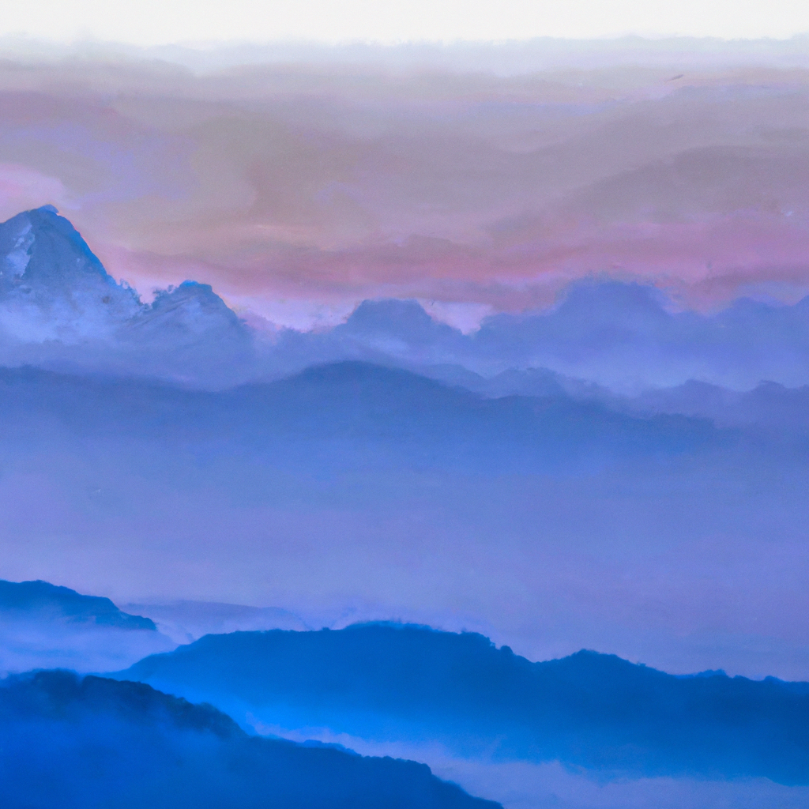“The Himalayan mountain ranges in the style of a Nepali painting”, generated by DALL·E 2

Problem to Solve
You are a census taker working for the Nepali government. As you crest one final hill, your breath catches at the sight of a Himalayan sunrise, casting a glow on the village you’ve journeyed so far to reach. Your guide, a local, halts abruptly. Underneath the steady rustle of your census papers, you feel an itch of curiosity. After all, it’s not every day your job takes you to a village like this one.
In census.db, process your data into views the Nepali government can use for record-keeping.

Demo

Distribution Code
For this problem, you’ll need to download census.db, along with a few .sql files in which you’ll write your queries.
Download the distribution code

Schema
In census.db you’ll find a single table, census. In the census table, you’ll find the following columns:
- id, which uniquely identifies each census record
- district, which is the name of the census record’s district
- locality, which is the name of the census record’s locality within the district
- families, which is the number of families associated with the census record
- households, which is the total number of households associated with the census record (multiple families may live in the same household)
- population, which is the population associated with the census record
- male, which is the number of people associated with the census record who have identified as male
- female, which is the number of people associated with the census record who have identified as female

Specification
In each of the corresponding .sql files, write a SQL statement to create each of the following views of the data in census.db. Note that, while views can be created from other views, each of your views should stand alone (i.e., not rely on a prior view).

Rural
In rural.sql, write a SQL statement to create a view named rural. This view should contain all census records relating to a rural municipality (identified by including “rural” in their name). Ensure the view contains all of the columns from the census table.

Total
In total.sql, write a SQL statement to create a view named total. This view should contain the sums for each numeric column in census, across all districts and localities. Ensure the view contains each of the following columns:
- families, which is the sum of families from every locality in Nepal.
- households, which is the sum of households from every locality in Nepal.
- population, which is the sum of the population from every locality in Nepal.
- male, which is the sum of people identifying as male from every locality in Nepal.
- female, which is the sum of people identifying as female from every locality in Nepal.

By District
In by_district.sql, write a SQL statement to create a view named by_district. This view should contain the sums for each numeric column in census, grouped by district. Ensure the view contains each of the following columns:
- district, which is the name of the district.
- families, which is the total number of families in the district.
- households, which is the total number of households in the district.
- population, which is the total population of the district.
- male, which is the total number of people identifying as male in the district.
- female, which is the total number of people identifying as female in the district.

Most Populated
In most_populated.sql, write a SQL statement to create a view named most_populated. This view should contain, in order from greatest to least, the most populated districts in Nepal. Ensure the view contains each of the following columns:
- district, which is the name of the district.
- families, which is the total number of families in the district.
- households, which is the total number of households in the district.
- population, which is the total population of the district.
- male, which is the total number of people identifying as male in the district.
- female, which is the total number of people identifying as female in the district.

Usage
To test your views as you write them in your .sql files, you can run a query on the database by running
.read FILENAME
where FILENAME is the name of the file containing your SQL query. For example,
.read rural.sql
Keep in mind you can also use
DROP VIEW name;
where name is the name of your view, to remove a view before creating it anew.

How to Test
While check50 is available for this problem, you’re encouraged to also test your code on your own. You might try queries like the below:
- How many rural districts are there? How many families live in rural districts? Using your rural view, you should find there are 461 rural districts with 2,229,834 families.
- How many households are in Nepal? Using your total view, you should find there are 5,642,674.
- Which district has the second lowest number of families? And how many does it have? Using your by_district view, you should find that the Mustang district has only 3,751 families.
- Which district has the highest population? And how many households are in that district? Using your most_populated view, you should find that the most populated is Kathmandu with 275,806 households.

